**The Holistic perception Harmony and Existence**

**Development of a Holistic Perspective**

The outcome of value education is a holistic perspective with the clarity about human being (the one who understands), about the nature/existence of which we are an integral part as well as our participation in this nature/ existence. This participation is our role, it is our purpose, it is our right, it is our responsibility and it is our value. In terms of day-to-day living, it means that we are able to see our role with respect to ourselves, with respect to the family, with respect to the society and with respect to nature/existence (fig. 1-1). We can also see that we feel happy when we fulfil our participation at any level.

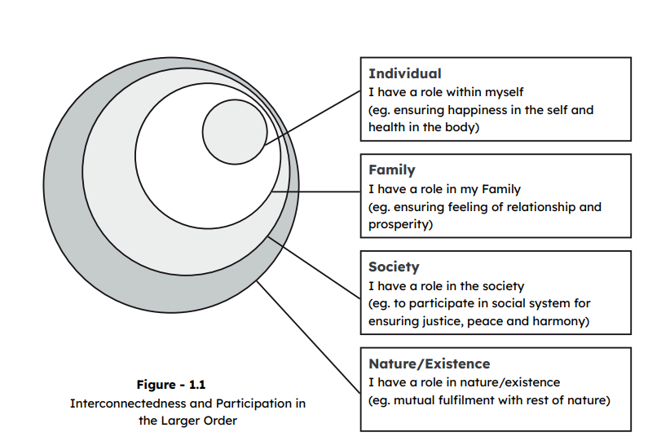

We are interconnected, interrelated in this existence – from the smallest level to the whole cosmos. There is a chain of connectedness with mutual fulfilment at every level. With a holistic perspective we are able to see every little part of it. We can also see that our own existence is by virtue of this mutual fulfilment. It is the same for other human beings as well as all the units in nature, like air, water, plants and animals. The rich bio-diversity is fulfilling for us and is readily available to us without any effort from our side. It is like a gift of mutual fulfilment. All the wisdom, information and skills which the long human tradition has developed are also readily available to us without any effort from our side. This also develops a deep sense of gratitude for the society and ultimately for the whole existence. In the light of the holistic perspective, we can understand that the nature or the existence is in harmony and there is relationship among all the units of nature, including human beings. We can now perceive that the harmony, the relationship is the running thread across all that exists, across all the units in nature – from a single atom to the whole cosmos. We can now see that, in fact, all these units, from atoms to cosmos, are the expressions of this harmony and relationship at different levels.

**Clarity of Programme to Live with Holistic Perspective**

We are all faced with many questions regarding our program of living, such as: what thoughts are naturally acceptable to me with which I would like to continue, what food will keep my body healthy which clothes will fulfil the need of my body better, what behaviour with my friends will sustain our relationship, how I can be a help to the other in my family, how I can participate in the college or neighbourhood or the society at large so that there is mutual fulfilment, what my role can be in maintaining the harmony of the environment which includes trees, air, water, etc. We all have such concerns and we keep struggling with confusion about all these aspects and the notions vary from person to person. Can we get a vision, a programme that can be holistic as well as universal? This will give us the clarity to work out the day-to-day programs. Value Education provides us the vision which will help us to get answers to get answers to all these questions. We can see that this clarity of programme is necessary for our own state of happiness.

**Evaluation of our Beliefs**

Our conduct depends on what we understand or believe about ourselves, our family, the society and the nature around. Value education also helps us become aware of our own beliefs. Much of our behaviour or working is based on beliefs about which we are ourselves quite unaware of. These somehow become the guiding factors of the decisions of our life. Hence, it is important to evaluate our own beliefs sincerely. Of course, all beliefs are not wrong, but there may be many that are. For example, if we believe that earning money is the ultimate goal of life and sensual pleasures are the only source of happiness, we make effort for accumulating money and indulging in sensual pleasures as much as possible. Like that, there may be many different beliefs and based on these beliefs, different programs for fulfilment. One of these beliefs could be that the very design of nature is such that there is struggle for survival and the ‘survival of the fittest’; and that human beings have to struggle their way through life. With this belief, invariably we think in terms of competition, instead of cooperation with human beings; we may even think of domination which may ultimately lead to fighting and even war. We may think in terms of accumulating more and more physical facility. For this we think of exploitation and mastery over rest of nature, instead of ensuring mutual enrichment. This may ultimately lead to resource depletion and environment pollution. We can see that the major problems that we see today in the society, have their seeds in the wrong beliefs that we have in us about ourselves and about the rest of nature.

Do you know for sure what exactly your beliefs are – about human being and about this nature/existence? Is there struggle for survival and survival of the fittest in nature? Is the cosmos in harmony or heading toward chaos? A belief is an assumption which we are not sure of, but since it has been reinforced over and over again, we also tend to hold it and repeat it. Inside, we also don’t know, we are also not sure! On the other hand, understanding means knowing without doubt what it actually is. At the collective level, the culture and civilisation are characterised by the understanding or belief about these two entities: one about the human being, and the other about the nature/existence. The society propagates its understanding or beliefs through education to the next generation. Of course, here education means all the inputs that an individual absorbs from the family, the school/college as well as the larger society – through people, practices, festivals, media, etc. Find out if you are getting these inputs. Find out if you are drawing some conclusions out of these inputs. Find out if you are setting your goals with these inputs.

**Solution of Existing Problems**

If we understand our participation (human values) and live by them in the complete expanse of our being (from ourselves to family, to society and to the entire nature), it will lead to a fulfilling life for ourselves and fulfilling for all around. The problems, including wrong beliefs, are mainly because we do not have understanding and we are not making enough effort for it. Once we have a holistic perspective and the clarity of the programme to live by it, we are able to realise that most of the existing problems are actually symptoms and consequences of our wrong beliefs. Then, in due course of time, we will be able to root them out, not only at the personal level, but also at the family level, in our workplace, at societal level and in our interaction with the rest of nature. With right understanding of things, we are better able to define our role in different phases of life and work accordingly. One thing that happens with such inputs is that we do not create problems for ourselves or others; secondly, we are able to resolve the existing problems at different levels of our living; and thirdly, we are able to lay down a programme, whatever be the scale which does ensure fulfilment for all. Thus, we are able to participate in the collective fulfilment of the society around.

**Development of Ethical Competence**

Ethics is the expression of definite human conduct in one’s behaviour, work or participation in the larger order. It is easy to appreciate that the core purpose of value education is to develop ethical competence among human beings which will reflect in all their pursuits. The problem of unethical conduct in various professions which is becoming a grave menace almost everywhere, can also be tackled effectively by focussing attention on development of ethical competence through human value education. We shall discuss in detail about the salient implications of value education in context with professional ethics in the third section of the book.

**Guidelines for Value Education**

Now that we have identified the need and implications of value education, let us visualize certain effective and widely acceptable guidelines which will enable the introduction of value education in the present academic system. Given below are the broad guidelines:

**Universal**

Whatever we study as value education has to be universally applicable to all human beings and be true at all times and all places. This implies that it should not change depending upon sect, creed, nationality and gender, etc. It has to deal with universal human values For example, the feeling of respect in relationship is something universal, so it can be a part of value education.

**Rational**

It has to be amenable to reasoning and not based on dogmas or blind beliefs. It should be open to address the related questions. It cannot be a set of sermons or do’s and don’ts.

**Natural and Verifiable**

We want to study something that is natural to us. Being natural means, it has to be acceptable in a natural manner. When we live on the basis of such values that are natural to us, it leads to mutual fulfilment. It leads to our happiness and it is also conducive to the happiness of other people we interact with, as well as enriching for other units in nature. We also want to verify these values ourselves, i.e., we don’t want to assume something just because it is being stated here; rather, each one of us wants to verify these to find out whether they are true for us. This can be done by both checking for validity within ourselves, as well as something which we can implement in our living and observe its outcome.

**All Encompassing**

The content of value education has to cover all dimensions of our being (thought, behavior, work and understanding) as well as all levels of our living (individual, family, society and nature/existence). It is not merely an intellectual exercise or information transfer.

**Leading to Harmony**

Finally, value education has to enable us to be in harmony within and in harmony with others. Hence, when we live on the basis of these values, we start observing that it leads to harmony in us and harmony in our interactions with other humans and the rest of nature.

**Content of Value Education**

We have seen that the value of a human being is the participation of the human being in the larger existential order. Hence, to understand human values, we need to study human being along with all that is there in the existence. The role of human being is the relationship with each and every unit in the existence. That means the scope of study has to be all encompassing, i.e. • It covers all dimensions of human being – thought, behaviour, work and realisation. • It covers all levels of human living – individual, family, society, nature and existence. Accordingly, the content of Value Education has to be to understand human being, human aspirations, happiness; understand the goal of human life comprehensively; understand the other entities in nature, the innate interconnectedness, the harmony in the nature/existence and finally the role of human being in this nature/existence. Hence, it has to encompass understanding of harmony at various levels, namely, individual, family, society, nature and existence, and finally, learning to live in accordance with this understanding by being aware of one’s thought, behaviour and work.

**Process of Value Education – Self-exploration**

Human Values can be understood by an appropriate process of selfdiscovery, because they are potentially there in each and every human being. There is already a natural acceptance for values in a human being. It is only that we have to discover them or become aware of them. For example, if you are asked, what is naturally acceptable to you: the feeling of relationship or feeling of opposition with other members of your family? Just observe within for the answer. The natural response is feeling of relationship. This feeling of relationship is a value for us. In this discussion, this feeling was not created in you. You already had the acceptance for it. It was only uncovered by drawing your attention within though the question for exploration. Hence, to study human values, the process has to be such that it develops a process of self-exploration in you. Taking every statement as a proposal, you are able to investigate the reality by yourself. Value education is not a set of do’s and don’ts or a set of sermons. It rather is a process of self-exploration and self-investigation. This will be further elaborated in the next chapter.

**Salient Points**

* We are all seeking and working for a fulfilling, harmonious life. It is something we consider valuable, something of value
* The value of any entity is its participation in the larger order of which it is a part. With a holistic perspective, we can see that a human being participates at the level of individual as well as at the levels of family, society and nature/existence. The value of a human being is its participation that leads to harmony at all these levelsValue education is that part of education which deals with understanding one’s participation in the larger order, and thus ensuring it in living.
* It is essential that any content on value education be universal, rational, natural, verifiable, all-encompassing and leading to harmony.
* The content of value education must be all encompassing, i.e., it must include all dimensions of a human being as well as all levels of human living.
* The process of value education is essentially a process of selfexploration (self-reflection and self-discovery). Self-exploration includes self-verification at the level of natural acceptance and experiential validation in living.
* Ethics is the expression of definite human conduct in one’s behaviour, work or participation in the larger order which is a result of right understanding about ourselves vis-à-vis rest of nature.
* Development of ethical competence in the individual is the way to ensure professional ethics.